Q1.Write a Python script to perform below operations on list
a.Initialize a list lst=[ 1.5, “Python”, -5, 4, 0.8, -3.2, ‘C++’]
b.Add 0.8 to the list
c.Add [4,1.5,6,0.8] to the existing list
d.Insert any element at position 2.
e.Remove ‘C++’ from the list.
f.Remove element at position 5.
g.Find out the index of element 5.
h.Find out the occurrence of element 4.
i.Slice the list from 2 nd to 6 th position.
j.Reverse the list.
k.Create a copy of this list and display.

CODE:
lst=[1.5, "Python" ,-5, 4, 0.8, -3.2, 'C++']
lst.append(0.8)
print("Aftre Appending 0.8")
print(lst)
add= [4,1.5,6,0.8]
lst.append(add)
print("Aftre Appending list add ")
print(lst)
lst1=[1.5, "Python" ,-5, 4, 0.8, -3.2, 'C++']
lst1.insert(2,20)
print("Aftre Adding element at second position ")
print(lst1)
lst1.remove('C++')
print("Aftre removing C++")
print(lst1)
lst1.pop(5)
print("Aftre removing element at 5th position ")
print(lst1)
pos= lst1.index(-5)
print("Position of element of -5 ")
print(pos)
ct=lst1.count(4)
print("Occurences of element 4 ")
print(ct)
print("List from 2 to 6 position ")
print(lst1[2:6])
lst1.reverse()
print("print list aftre reversing ")
print(lst1)
copy=lst1 ## copy the list
print("Aftre copying list lst1 wieh copy ")
print(copy)

OUTPUT
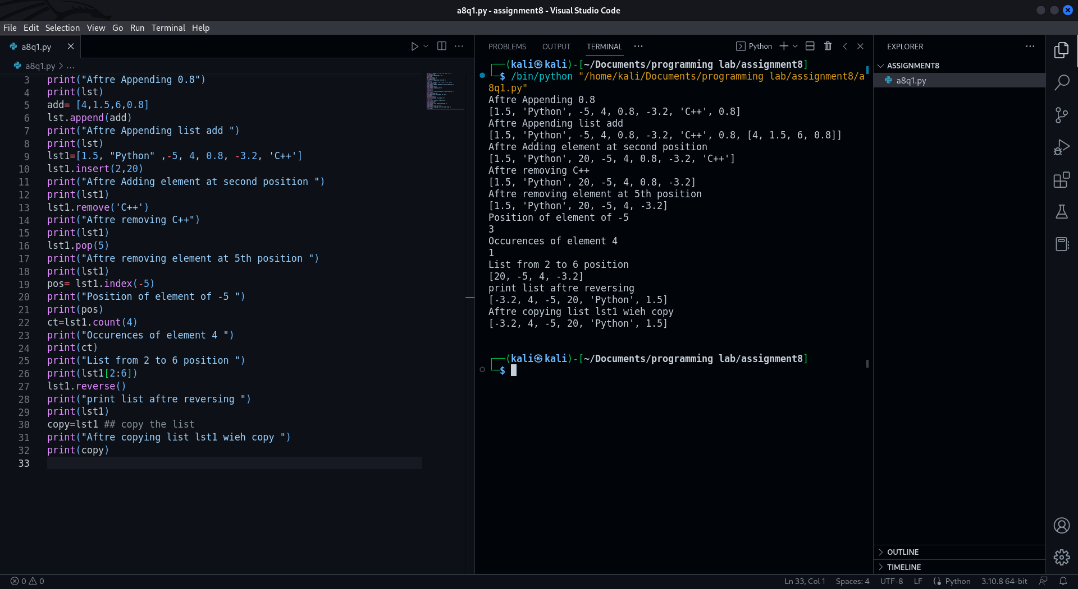

Q2.Write a Python script to perform below operations on Dictionary
a. Create a dictionary
b. Print keys and values of dictionary
c. Search for a specific key, if found, display its value, if not display default
value.
d. Add new key and value
e. Remove any element
f. Copy this dictionary
g. Find out length of dictionary
h. Delete the dictionary

CODE:
dictionary=dict({1:"a",2: "b",3:"c",4:"d",5:"e"})
print("Printing Dictionary with keys and values ")
print(dictionary)
print(dictionary.get(6))
dictionary[6] = "f"
print(dictionary)
dictionary.pop(5)
print(dictionary)
new_dic = dictionary
print(new_dic)
print(len(dictionary))
dictionary= None
print(dictionary)

OUTPUT:
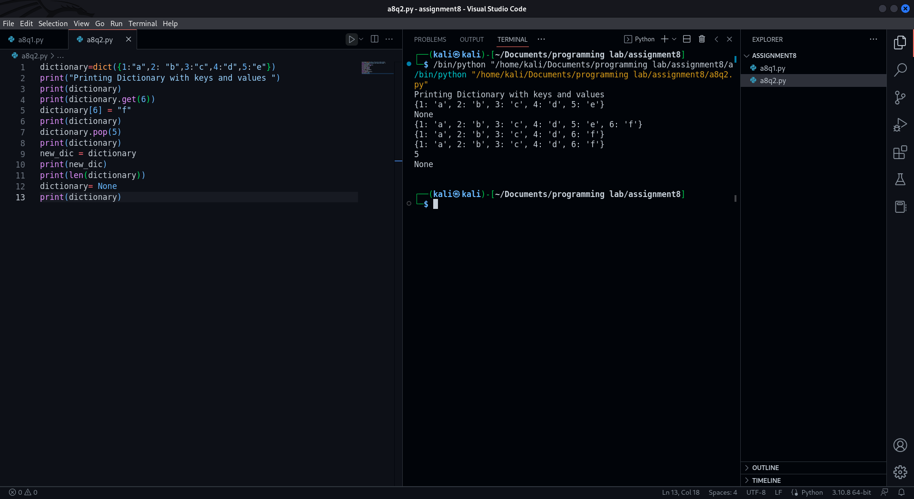

Q3.Create a function in python to perform swapping of two numbers using
a. Temporary variable
b. No Temporary variable

CODE:
a=5
b=7
print("Using temprory varible ")
temp=a
a=b
b=temp
print(a,b)
print("without using print varible ")
a=a^b
b=a^b
a=a^b
print(a,b)

OUTPUT:
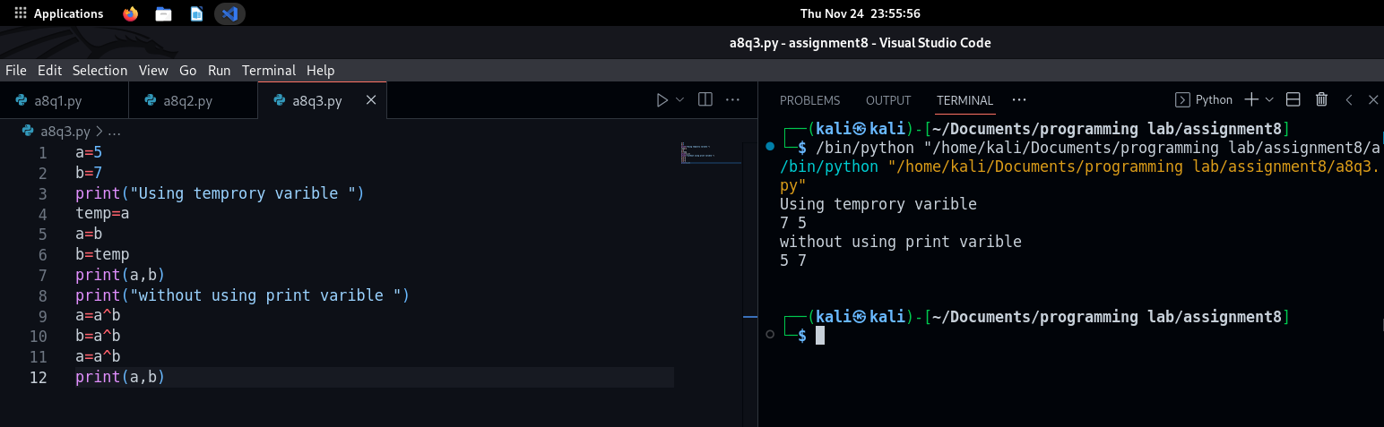

Q4.Create a function in python to accept and return multiple arguments.
CODE:
def lst(a,b):
sum=a+b
sub=a-b
return "sum is " + str(sum) , "sub is "+ str(sub)
sum ,sub = lst(9,7)
print(sum,sub)

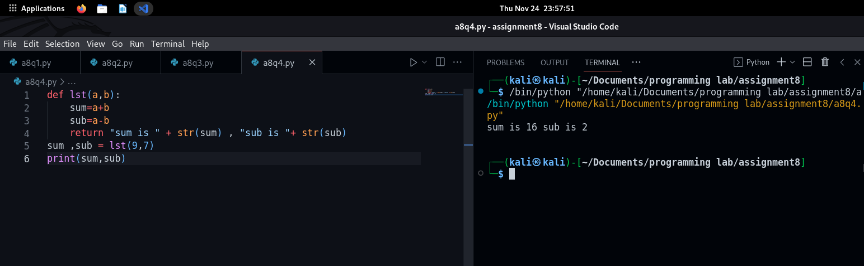
OUTPUT:

